**Objectives: Write RMI program to add two numbers.**

**Theory:**

**RMI:**

The RMI (Remote Method Invocation) is an API that provides a mechanism to create distributed application in java. The RMI allows an object to invoke methods on an object running in another JVM. The RMI provides remote communication between the applications using two objects stub and skeleton.

**Source Code:**

**//define remote interface**

import java.rmi.*;

public interface AddRem extends Remote

{

public int addNum(int a, int b) throws RemoteException;

}

**//implementation of interface**

import java.rmi.*;

import java.rmi.server.UnicastRemoteObject;

public class AddRemImp1 extends UnicastRemoteObject implements AddRem

{

public AddRemImp1() throws RemoteException{

}

public int addNum(int a, int b){

return (a+b);

}

}

**//client program**

import java.rmi.*;

import java.net.*;

import java.util.*;

public class AddClient {

    public static void main(String args[]) {

        Scanner sc;

        try {

            String host = "localhost";

            sc = new Scanner(System.in);

            System.out.println("Enter the 1st parameter");

            int a = sc.nextInt();

            System.out.println("Enter the 2nd parameter");

            int b = sc.nextInt();

            AddRem remobj = (AddRem) Naming.lookup("rmi://" + host + "/AddRem");

            System.out.println(remobj.addNum(a, b));

        } catch (RemoteException re) {

            re.printStackTrace();

        } catch (NotBoundException nbe) {

            nbe.printStackTrace();

        } catch (MalformedURLException mfe) {

            mfe.printStackTrace();

        }

    }

}

**//server program**

import java.rmi.*;

import java.net.*;

public class AddServer

{

public static void main(String args[])

{

try{

AddRemImp1 locobj= new AddRemImp1();

Naming.rebind("rmi:///AddRem",locobj);

}

catch(RemoteException re){

re.printStackTrace();

}

catch(MalformedURLException mfe){

mfe.printStackTrace();

}

}

}

**Output:**

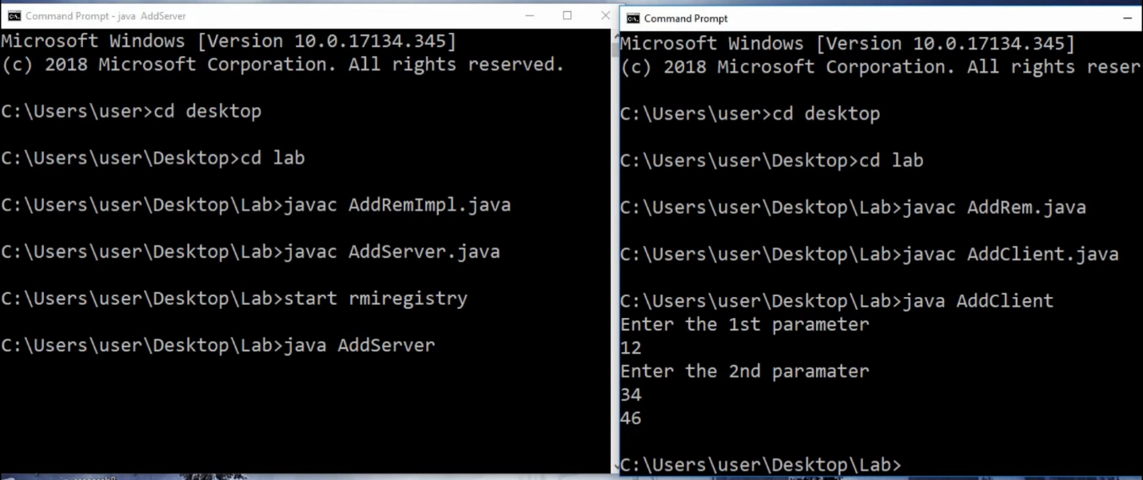

**Conclusion:**

In this lab of Advanced Java Programming, we successfully implemented the concept of Remote Method Invocation (RMI) using Java programming language.